**Interpolation**

**Gauss’ Forward And Backward Difference Formula**

**Theory**

Gauss’ forward formula is considered that the following difference table in which the central ordinate is taken for convenience as y0 corresponding to x = x0 . The differences used in this formula lie on the line shown in the following table –

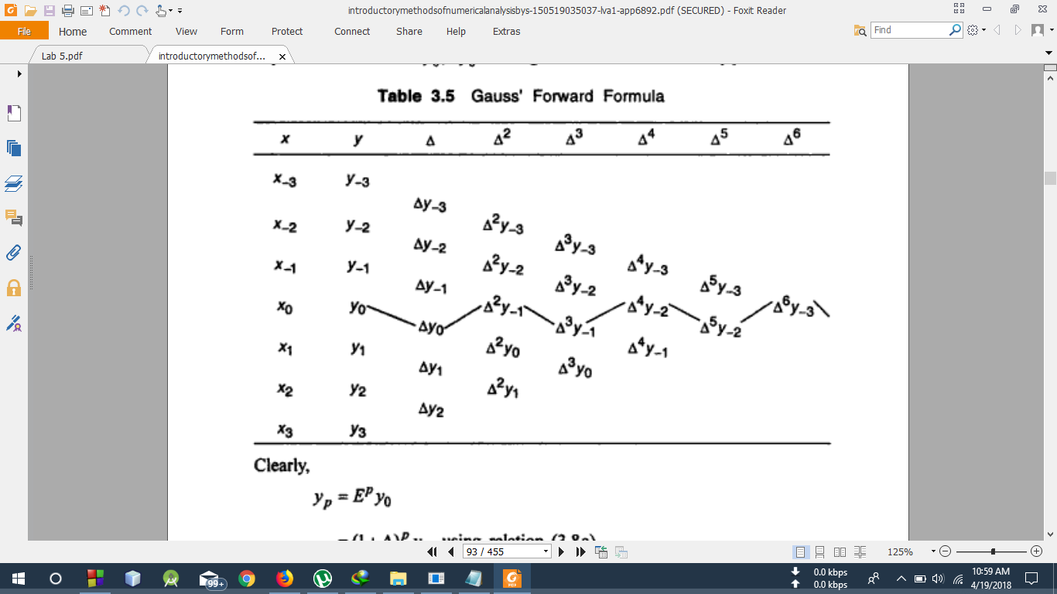

The formula is therefore of the form,

yp = G1∆y0 + G2∆2y-1 + G3∆3y-1 + G4∆4y-2 + …. ______ (1)

Where G1, G2, G3, G4 , h, p are ,

h = (x1 – x0)

p =

G1 = p

G2 =

G3 =

G4 =

Gauss’ backward formula uses the difference which lie on the line that shown in the table below-

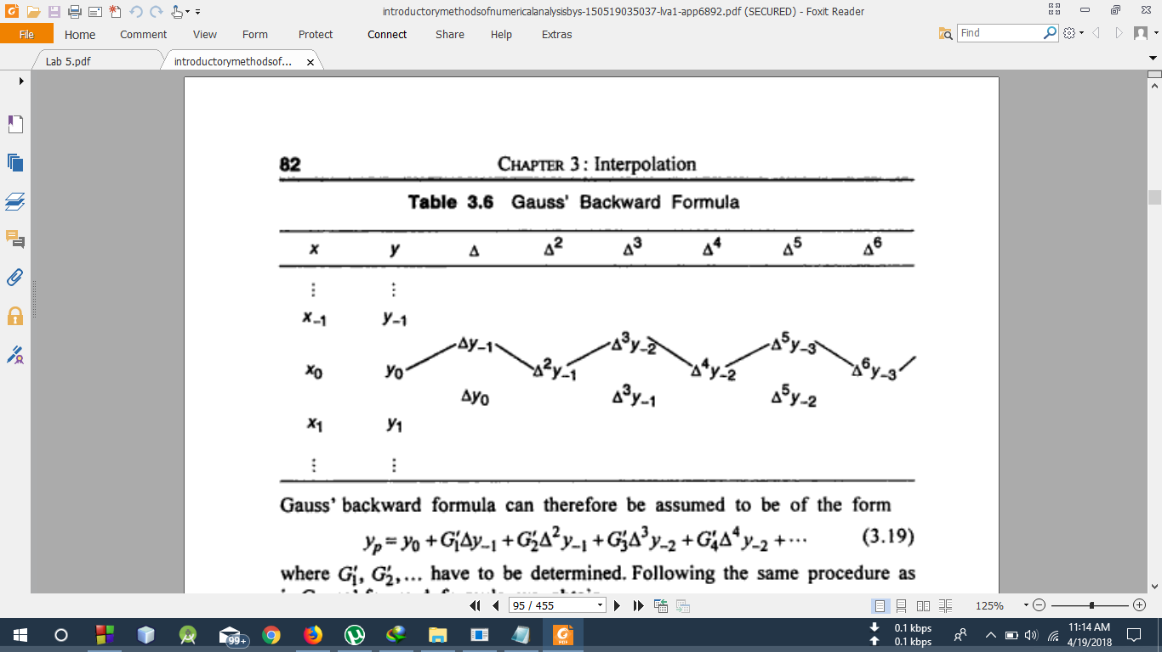

Gauss’ backward formula can therefore be assumed to be of the form,

yp =G’1∆y-1 + G’2∆2y-1 + G’3∆3y-2 + G’4∆4y-2 + …. _____ (2)

Where G’1, G’2, G’3, G’4, h, p are ,

h = (x1 – x0)

p =

G’1 = p

G’2 =

G’3 =

G’4 =

**Code**

#include<bits/stdc++.h>

using namespace std;

int fact(int n)

{

if(n==0 || n==1)

return 1;

else if(n>1)

return n*fact(n-1);

}

void PrintForward(double x[],double y[],double Del1[], double Del2[], double Del3[])

{

int i,j;

cout<<"\nx y Del1y Del2y Del3y"<<endl;

cout<<"-------------------------------------------------"<<endl;

for(i=0 ; i<4 ; i++)

printf("%0.0lf %0.5lf %0.5lf %0.5lf %0.5lf\n",x[i],y[i],Del1[i],Del2[i],Del3[i]);

cout<<"-------------------------------------------------"<<endl;

}

void PrintBackward(double x[],double y[],double Del1[], double Del2[], double Del3[],double Del4[])

{

int i,j;

cout<<"\nx y Del1y Del2y Del3y Del4y"<<endl;

cout<<"-----------------------------------------------------------------"<<endl;

for(i=0 ; i<5 ; i++)

printf("%0.0lf %0.5lf %0.5lf %0.5lf %0.5lf %0.5lf\n",x[i],y[i],Del1[i],Del2[i],Del3[i],Del4[i]);

cout<<"-----------------------------------------------------------------"<<endl;

}

void Forward()

{

int points,i,j=0,k=0,l=0;

double x[10],y[10],h,p,X,Del1[10],Del2[10],Del3[10],Y,G1,G2,G3;

for(int x=0;x<10;x++)

{

Del1[x] = 0; Del2[x] = 0; Del3[x] = 0;

}

cout<<"\nHow many points? : ";

cin>>points;

cout<<endl;

for(i=0;i<points;i++)

{

cout<<"Enter the value of x"<<i<<" : " ;

cin>>x[i];

cout<<"Enter the value of y"<<i<<" : ";

cin>>y[i];

}

printf("\n");

cout<<"For which value of x, the value of y will be determined: ";

cin>>X;

h = x[1] - x[0];

p = (X - x[1])/h;

for(i=0;i<points-1 ; i++)

Del1[i] = y[i+1] - y[i];

for(i=0;i<points-2 ; i++)

Del2[i] = Del1[i+1] - Del1[i];

for(i=0;i<points-3 ; i++)

Del3[i] = Del2[i+1] - Del2[i];

PrintForward(x,y,Del1,Del2,Del3);

G1 = p;

G2 = (p*(p-1))/fact(2);

G3 = ((p+1)*p*(p-1))/fact(3);

Y = y[1] + G1*Del1[1] + G2*Del2[1] + G3*Del3[0];

cout<<"\nThe value of Y("<<X<<") is: " <<Y<<endl;

}

void Backward()

{

int points,flag=0,i,j=0,k=0,l=0;

double x[10],y[10],h,p,X,Del1[10],Del2[10],Del3[10],Del4[10],Y,G1,G2,G3,G4;

for(int x=0;x<10;x++)

{

Del1[x] = 0;

Del2[x] = 0;

Del3[x] = 0;

Del4[x] = 0;

}

cout<<"\nHow many points? : ";

cin>>points;

cout<<endl;

for(i=0;i<points;i++)

{

cout<<"Enter the value of x"<<i<<" : " ;

cin>>x[i];

cout<<"Enter the value of y"<<i<<" : ";

cin>>y[i];

}

printf("\n");

cout<<"For which value of x, the value of y will be determined: ";

cin>>X;

h = x[1] - x[0];

p = (X - x[1])/h;

for(i=0;i<points-1 ; i++)

Del1[i] = y[i+1] - y[i];

for(i=0;i<points-2 ; i++)

Del2[i] = Del1[i+1] - Del1[i];

for(i=0;i<points-3 ; i++)

Del3[i] = Del2[i+1] - Del2[i];

for(i=0;i<points-3 ; i++)

Del4[i] = Del3[i+1] - Del3[i];

PrintBackward(x,y,Del1,Del2,Del3,Del4);

G1 = p;

G2 = (p*(p+1))/fact(2);

G3 = ((p+1)*p*(p-1))/fact(3);

G4 = ((p+1)*(p+2)*p*(p-1))/fact(4);

Y = y[1] + G1*Del1[1] + G2*Del2[0] + G3*Del3[0] + G4*Del4[0];

cout<<"\nThe value of Y("<<X<<") is: " <<Y<<endl;

}

void menu()

{

int choice;

cout<<"1.Gauss's Forward Interpolation\n2.Gauss's Backward Interpolation\n3. Exit\nEnter your Choice: ";

cin>>choice;

switch(choice)

{

case 1:

Forward(); break;

case 2:

Backward(); break;

case 3:

cout<<"The program ended successfully" <<endl; break;

default:

cout<<"wrong Input"<<endl; break;

}

}

int main()

{

menu();

return 0;

}

**Output**

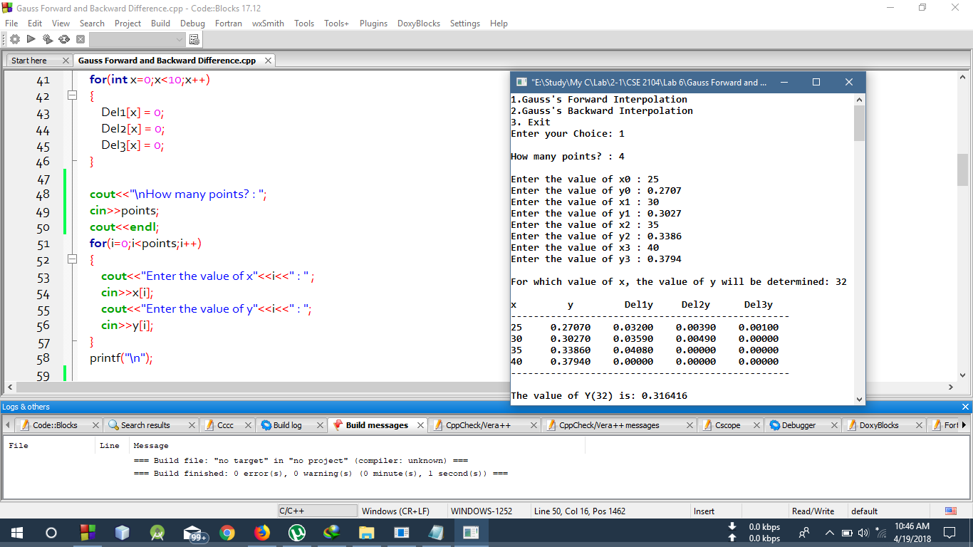

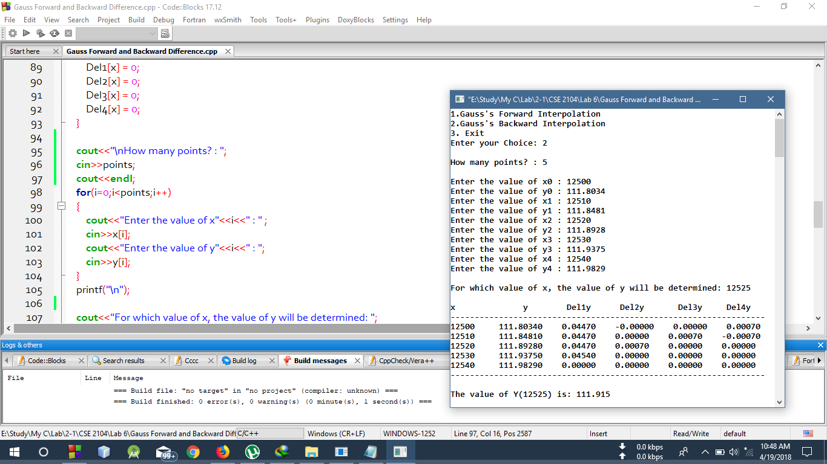

**Discussion**

Here, in the above code , A menu() function was used to get the Gauss’ forward difference table, and backward Difference table which was used to get the required result. In the menu() function,  
Forward(), Backward() function was called. In the Forward() function, PrintForward() was  
called to generate the Forward Difference table and similarly PrintBackward() was called in the  
Backward() function to generate the backward difference table. Thus Using the equation (1) and  
(2) the result for forward difference and backward difference was shown respectfully